PLEASE COMPLETE THIS FORM AND SEND IT TO MY EMAIL ADDRESS:
trifbookdesign@gmail.com
Thank you for your interest in working with us.

Y O U R D A T A
G I V E U S S O M E I N F O R M A T I O N A B O U T Y O U

First Name *:
Last Name *:
Email Address *:
Confirm Email Address *:
How did you hear about us? From someone, from social media, from Amazon etc.
-
TRIFBOOKDESIGN DISCOUNT PROGRAM (more details in the bottom of this form)
Have you heard about us from someone? Tell us their name and they will earn DISCOUNTS on their next orders.
REFERRAL SECTION - AUTHOR NAME:

B O O K D E T A I L S
T H E F O L L O W I N G I N F O R M A T I O N W I L L B E U S E D T O D E S I G N Y O U R C O V E R

Title * (Please indicate the Title exactly as it should appear on the cover)
-
Author * (Please indicate the Author Name exactly as it should appear on the cover)
-
Additional Front Cover Text (If applicable)
-
Genre * (What genre would you consider your book?)
-
Brief synopsis of the book * (Please provide a detailed synopsis of your book including setting, plot overview, descriptions of main characters, conflict, themes, and tone)
-
Key elements * (Please describe some key elements of the book, that you would consider appearing on the cover, e.g. Important locations, characters, items and/or themes):
-
Additional notes, suggestions or ideas (Feel free to tell us your ideas and maybe we can transform them into reality)
-
Give us any links or examples of covers you like. * (This is very important. Please paste links to book covers that you like or that you feel capture the essence of what you are looking for with your book. Feel free to explain why you chose these covers)
-

I M P O R T A N T
Please choose how you will pay:
- As a COMPANY/JURIDICAL PERSON/BUSINESS or as an INDIVIDUAL PERSON
All information is confidential and I need them only for invoices and accounting.
The Payment will be made via PayPal (I will send you an invoice from Paul Trif)

Company/Juridical Person/Business
Company Name:
ID/VAT Number (if you don’t have, leave it empty):
Country/State:
City:
Address:
PayPal address:
(From which you’ll going to make the payment)

Individual Person
First Name/Given name(s):
Last/Family Name(s):
Country/State:
City:
Address:
PayPal address:
(From which you’ll going to make the payment)
P R I C E S
Please write down which files do you need: example type (YES)
Paypal will convert the payment in any currency
Ebook 450€ EUR
Paperback Cover 100€ EUR
Additional printing service 20€ EUR (KDP/IngramSpark - One printing format is included in the package price)
Paperback+Hardcover 140€ EUR
Dust Jacket with flaps 60€ EUR
Audiobook Cover 70€ EUR
Facebook/still web banner 30€ EUR
One- sided Bookmark Design 30€ EUR
Two- sided Bookmark Design 40€ EUR
Blank Artwork + Separate title text 60€ EUR
Black&White (2pages wide) Interior Art 120€ EUR

Two Months Rush Fee Possibility (Get the cover in ≈2 months) 120€ EUR
One Month Rush Fee Possibility (Get the cover in ≈1 month) 140€ EUR
Urgent Fee Possibility (Get the cover in ≈2 weeks) 230€ EUR
One Week Fee Possibility (Get the cover in the next week) 280€ EUR

*ATTENTION! The price may vary depending on the complexity. I will request additional costs if there are more characters/animals/creatures on the cover. Additional price per characters and creatures:
-The First Character is included in the standard cover price.
-The Second Character (beside the first one) is at an additional 70€ EUR
-Interacting Couples 50€ EUR (Additional cost to the second character cost)
-For each new character you add another 40€ EUR (ex: Third Character 40€ EUR, Fourth 40€ EUR …)
-Animals/creatures (wolf, cat, dragon etc) 30 to 50€ EUR (depends on the size and placement)
P A P E R B A C K
You can tell me later if you don’t have all the info.

Paperback Trim Size (List the dimensions of the finished printed book (i.e., 5"x8" or 6"x9" etc.) :
Blurb for the back cover (You can tell us later if you don’t have it at this point):
Number of Pages (We’ll use this information to calculate the width of your book's spine):
Paper Color (For fiction books, cream paper is usually used, while white paper is the common choice for non-fiction. The paper thickness is also slightly different, which affects the spine width):
How will you be printing your Paperback? (KDP, Ingramspark etc.):

Interior Art Details (If Selected, it’s based on your cover details) (Please describe 1 or two elements of the book, that you would consider appearing on the interior art pages, e.g. Important locations, items and/or themes):

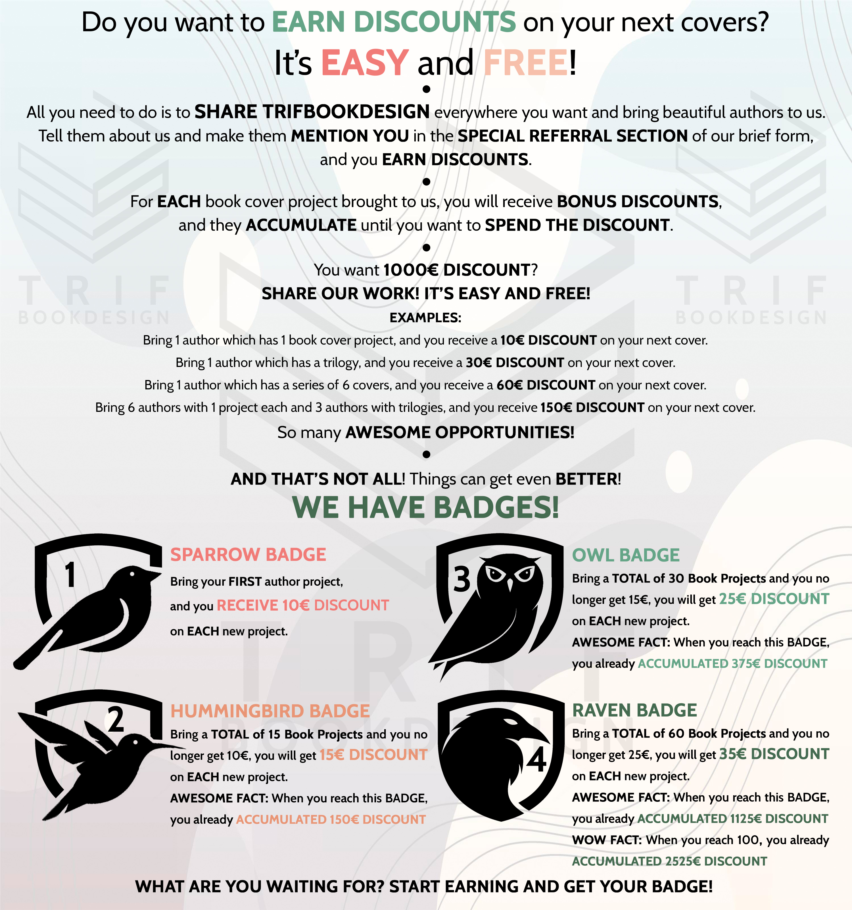
LINKS FROM WHERE YOU CAN GET PHOTOS OF OUR COVERS
TO START EARNING DISCOUNTS
Website: www.trifbookdesign.com
Facebook Group: https://www.facebook.com/groups/533186664040450/?mibextid=oMANbw

